Geoffrey Stoner

Z23238706

Database Structures COP3540

Database project

4/15/2015

Table setup:

CREATE TABLE student(sid INT, sname VARCHAR(30), sex CHAR, age INT, year VARCHAR(4), gpa DECIMAL(3,2) , PRIMARY KEY(sid));

CREATE TABLE dept(dname VARCHAR(25), numphds INT, PRIMARY KEY(dname));

CREATE TABLE prof(pname VARCHAR(30), dname VARCHAR(25), PRIMARY KEY(pname), FOREIGN KEY (dname)REFERENCES dept(dname));

CREATE TABLE course(cno INT, cname VARCHAR(30), dname VARCHAR(25), PRIMARY KEY(cno, dname), FOREIGN KEY (dname) REFERENCES dept(dname));

CREATE TABLE major(dname VARCHAR(25), sid INT, PRIMARY KEY (dname, sid), FOREIGN KEY (sid) REFERENCES student(sid), FOREIGN KEY (dname) REFERENCES dept(dname));

CREATE TABLE section(dname VARCHAR(25), cno INT, sectno VARCHAR(4), pname VARCHAR(30), PRIMARY KEY (dname , cno, sectno), FOREIGN KEY (dname) REFERENCES dept(dname), FOREIGN KEY (cno) REFERENCES course(cno));

CREATE TABLE enroll(sid INT, grade DECIMAL(3.2), dname VARCHAR(25), cno INT, sectno VARCHAR(4), PRIMARY KEY(sid), FOREIGN KEY (dname) REFERENCES dept(dname), FOREIGN KEY (cno) REFERENCES course(cno) );

TABLE SETUP Screenshots:

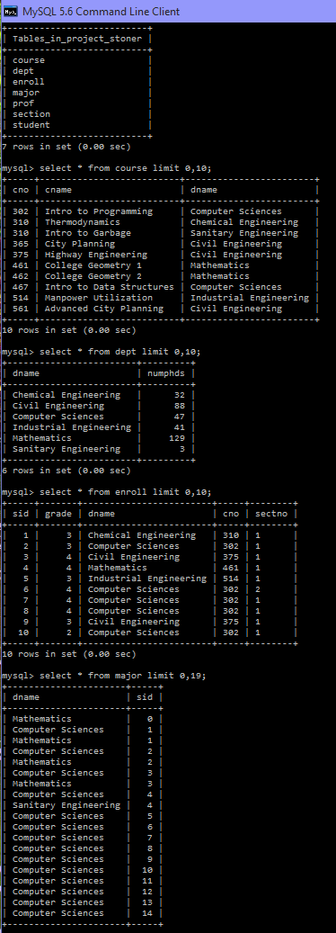

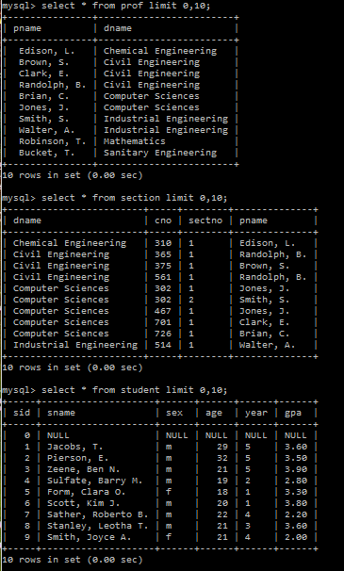

1. Print the names of professors who work in departments that have fewer than 50 PhD students.

SELECT pname

FROM prof P

WHERE EXISTS (SELECT \* FROM dept D

WHERE P.dname = D.dname AND numphds < 50);

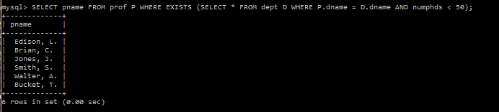

1. Print the name(s) of student(s) with the lowest gpa.

SELECT sname, gpa

FROM student

WHERE gpa < 2.00;

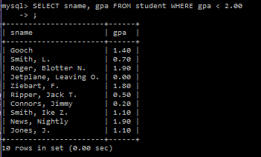

1. For each Computer Sciences class, print the cno, sectno, and the average gpa of the students enrolled in the class.

SELECT cno, sectno, (SUM(grade) / COUNT(grade))

AS gradeAvg

FROM enroll

WHERE dname = "Computer Sciences"

GROUP BY cno;

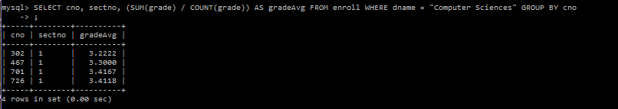

1. Print the course names, course numbers and section numbers of all classes with less than six students enrolled in them.

SELECT C.cno, C.cname, C.dname, E.sectno,

COUNT(E.sid) AS enrolled

FROM course C, enroll E WHERE C.cno = E.cno AND C.dname = E.dname

GROUP BY C.cname HAVING enrolled < 6;

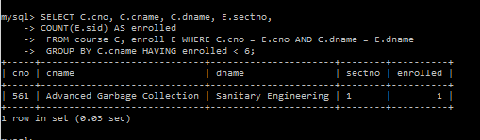

1. Print the name(s) and sid(s) of the student(s) enrolled in the most classes.

SELECT S.sname, S.sid,

COUNT(E.sid) AS numClasses

FROM student S, enroll E

WHERE S.sid = E.sid

GROUP BY E.sid

ORDER BY numClasses

DESC LIMIT 10;

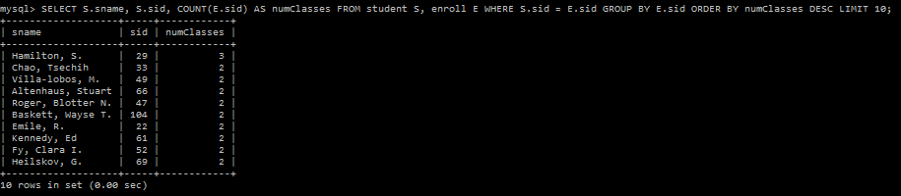

1. Print the names of departments that have one or more majors who are under 18 years old.

SELECT D.dname,

COUNT(S.sid)

AS numUnder18

FROM dept D,

major M, student S

WHERE D.dname = M.dname

AND M.sid = S.sid AND S.age < 18

GROUP BY D.dname;

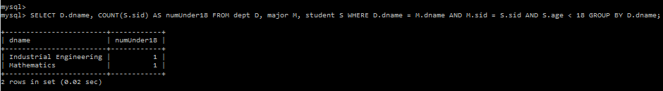

1. Print the names and majors of students who are taking one of the College Geometry courses. (Hint: You'll need to use the "like" predicate and the string matching character in your query.)

SELECT S.sname, M.dname

FROM course C, enroll E, major M, student S

WHERE C.cname

LIKE '%Geometry%' AND C.cno = E.cno AND C.dname = E.dname

AND E.sid = S.sid AND E.sid = M.sid;

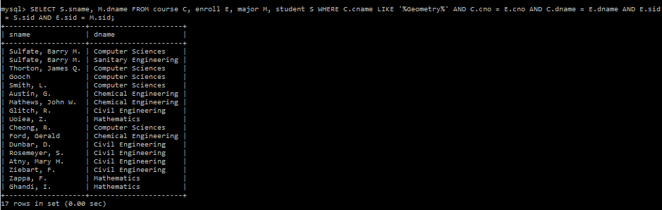

1. For those departments that have no majors taking a College Geometry course, print the department name and the number of PhD students in the department.

SELECT m.dname

FROM major m

LEFT JOIN( SELECT sid FROM enroll e

INNER JOIN course c ON c.cno = e.cno

WHERE c.cname in ('College Geometry 1', 'College Geometry 2') )m1

ON m1.sid = m.sid GROUP BY m.dname HAVING COUNT(m1.sid)=0;

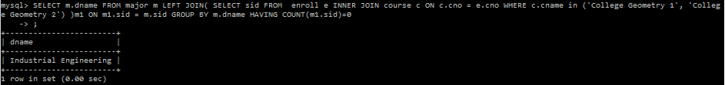

1. Print the names of students who are taking both a Computer Sciences course and a Mathematics course.

SELECT student.sname

FROM student

INNER JOIN enroll

AS enroll1 ON enroll1.sid = student.sid

AND enroll1.dname LIKE '%Computer Sciences%'

INNER JOIN enroll AS enroll2 ON enroll2.sid = student.sid

AND enroll2.dname LIKE '%Mathematics%'

GROUP BY student.sname;

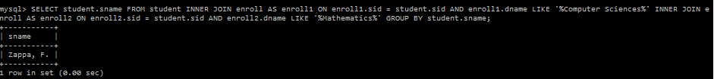

1. Print the age difference between the oldest and youngest Computer Sciences major(s).

select max(student.age)-min(student.age) "difference"

from student,major

where student.sid=major.sid and major.dname

LIKE '%Computer science%';

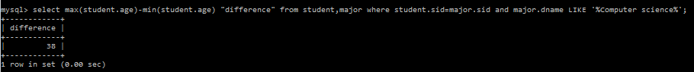

1. For each department that has one or more majors with a GPA under 1.0, print the name of the department and the average GPA of its majors.

select major.dname,avg(student.age)

from student,major

where student.sid=major.sid and student.gpa<1.0

group by major.dname;

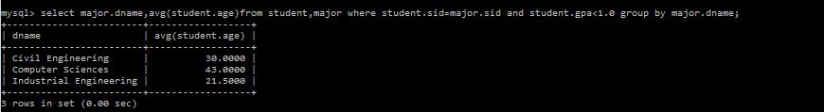

1. Print the ids, names, and GPAs of the students who are currently taking all of the Civil Engineering courses.

SELECT S.sid, S.sname, S.gpa

FROM student S, course C, enroll E

WHERE C.dname LIKE '%Civil engineering%'

AND C.cno = E.cno AND C.dname = E.dname AND S.sid = E.sid

GROUP BY S.sid

HAVING COUNT(S.sid) = 3;

